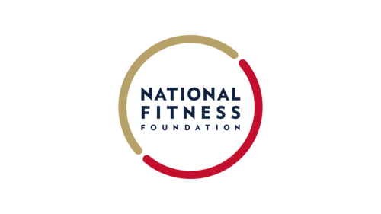
  - The American Youth Sports Pledge serves as a visual commitment to supporting and promoting youth sports for all children.

Andrew Gissinger III, former NFL player
Brian Fitzpatrick, Member of the United State House of Representatives
Carl Lewis, former Olympian
Cheri Bustos, Member of the United State House of Representatives
Herschel Walker, former NFL player
Jim Worthington, Owner of Newtown Athletic Club
John Harbaugh, head coach of the Baltimore Ravens
Jon Butler, Executive Director of Pop Warner
Keegan Rosenberry, professional soccer player
Keith Gordon, President & CEO of Fight for Children
Madeleine Dean, Member of the United State House of Representatives
Mary Owen, Life Trustee, Ralph Wilson Jr. Foundation
Max Scherzer, MLB player
Mike Kelly, Member of the United State House of Representatives
Mike Worch, President of Worch Financial Group
Rob Sgarlata, Head Football Coach, Georgetown University
Dr. Roger Goudy, President & CEO of AAU
Roger Williams, Member of the United State House of Representatives
Tim McDermott, CBO of the Philadelphia Union
Todd Levitt, CEO of Plate Vision
Tom Cove, Executive Director of SFIA
Tom McMillen, CEO of LEADI
William Lacy Clay Jr., Member of the United State House of Representatives

